COMMUNICATION FOR DEVELOPMENT (C4D) WORKSHOP
School of Public Health, University of the Witwatersrand, Johannesburg
Sunday, August 2 – Friday, August 14, 2015

ADMIN NOTES AND PRE-DEPARTURE AND
ARRIVAL INFORMATION

***Also print a copy of this to take along while traveling to the workshop***

Travel to Johannesburg and DSA

Travel to Johannesburg should be on economy class. Your country/regional office will provide you with DSA. One dinner (Thursday, August 13) and two lunches (Monday, August 10, and Friday, August 14) will be provided.

If you are travelling from outside South Africa, we recommend you arrive by Saturday evening, August 1st, giving you time to rest before the orientation session at 6:00 p.m. on Sunday August 2nd.

If you have a United Nations Laissez-Passer (UNLP), you do not need a visa for a stay of up to 90 days in South Africa. Holders of national passports of some countries also do not require visas. For the list of countries for which visas are not required and the visa exemption for UNLP holders see the South Africa Department of Home Affairs (DHA) web site:
http://www.dha.gov.za/index.php/countries-exempt-from-sa-visas

Please consult the DHA regulations and the visa office at UNICEF HQ in New York, if you have questions. If you travel on your own national passport, and your country is not exempt from visa requirements, you will need a visa. Please note that you should allow at least four weeks to obtain your visa.

If your flight is delayed, and you will not arrive in time for the Sunday orientation, please e-mail
Nicola Christofides at nicola.chris@gmail.com.

Immunization/vaccination

Visitors entering South Africa from a yellow fever zone must have a valid international yellow fever inoculation certificate. See Yellow Fever Vaccination Certificate Info in Admin Notes on course website. Only infants under the age of one year are exempt.
Vaccination should be approved by the World Health Organization (WHO) and administered at least 10 days before departure for South Africa as the vaccine offers protection 10 days after administration. If the vaccination is administered less than 10 days before departure, you may be refused entry. The following countries are considered to be in the Yellow Fever belt.

Africa:
Angola | Kenya
Burundi | Liberia
Benin | Mali
Burkina Faso | Mauritania
Cameroon | Niger
Central African Republic | Nigeria
Chad | Sao Tome and Principe
Congo  Democratic Republic  of Congo | Senegal
Equatorial Guinea | Sierra Leone
Ethiopia | Somalia
Gambia | Sudan
Gabon | Rwanda
Guinea | Tanzania
Guinea-Bissau | Togo
Ghana | Uganda
Ivory Coast

South America:
Argentina | Bolivia
Guyana | Brazil
Panama | Colombia
Peru | Ecuador
Surinam | French Guyana
Venezuela

Immunization against cholera and small pox are not required and no other vaccinations are required when visiting South Africa.

Workshop Contacts

Nicola Christofides, Workshop director
nicola.chris@gmail.com
mobile +2782 774 8547

Dr. David Mould, Workshop Director
davidmould@gmail.com

Orientation Session

The workshop begins with a mandatory orientation session starting at 6:00 p.m. on Sunday, August 2nd, with welcomes from university administrators and UNICEF. During the orientation, you will meet the other members of your team and team facilitator. This session will be followed by a reception. The orientation session will be held at:

Resource Centre, ground floor of the School of Public Health, located on the Wits Education Campus in Parktown.

Access to the building will be from York Road (opposite the Medical School at 7 York Road). Please note that the School of Public Health is located on the Parktown Campus, not on the main Wits University Campus in Braamfontein. Parking can be arranged for local participants: please contact Paul Bohloko, paul.bohloko@wits.ac.za.

Participants staying at the Sunnyside Park Hotel (see below) will meet in the lobby at 5:30 p.m. to walk to the School of Public Health. If you are not staying at the hotel, please make your own way by taxi. A workshop staff member will be outside the building to guide you through security and direct you to the room.

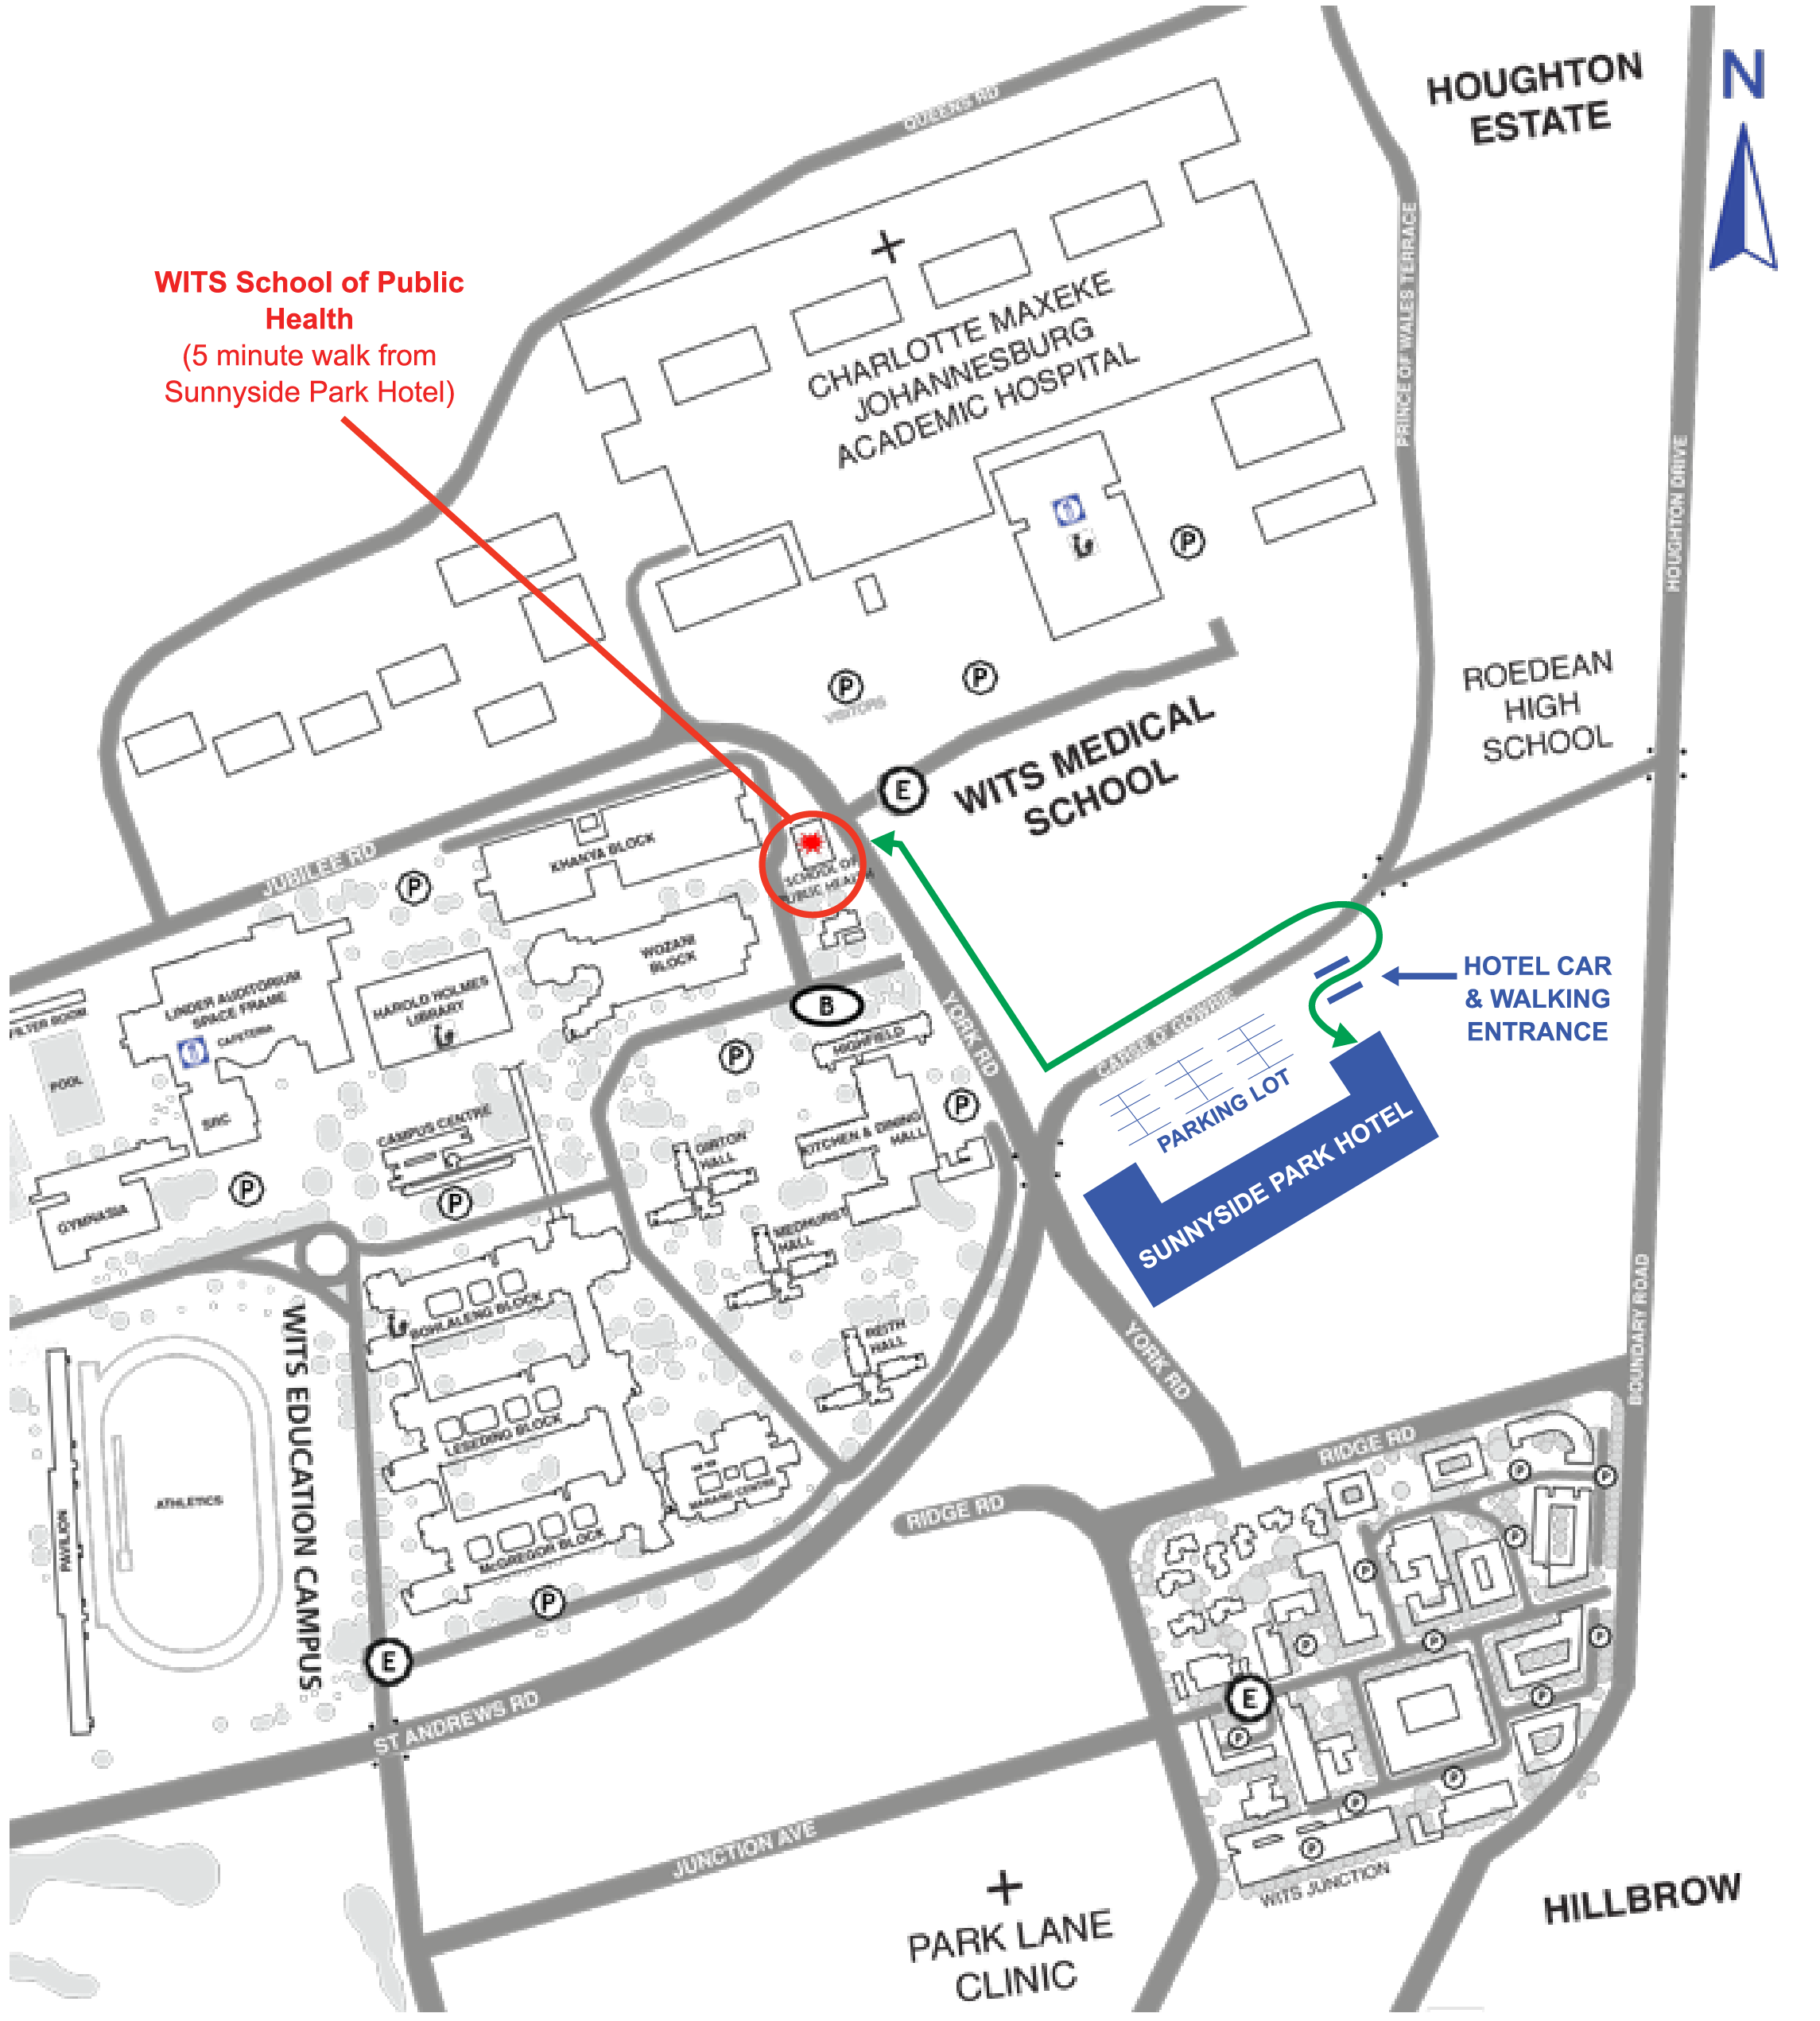

Accommodation

Most participants will be staying at the Sunnyside Park Hotel, http://www.sunnysidepark.co.za/ a 5-minute walk from the School of Public Health building where all workshop sessions will be held.

Address: Princess of Wales Terrace, Parktown, 2041
Phone + 27 (0) 11 640 0400; Fax: + 27 (0) 11 642 0019

We have reserved a block of rooms; a booking form with the special rate (about $84 per night for a single room, buffet breakfast included) is included below and in Admin Notes on the course website. To obtain the rate, please return the form to Mary Moloana at sunnyside1@legacyhotels.co.za
. If you would like to share a room, please contact other participants using the course Facebook page, https://www.facebook.com/groups/unicefc4d2012/ .
Other accommodation options are available but none are within easy walking distance of the School of Public Health. Taxis are available sometimes and also can be called, but they are expensive.

If you have reserved a room but did not include credit card information, the hotel cannot guarantee your reservation beyond 6: 00 pm on your scheduled date of arrival (since there may be other booking requests from guests with credit cards in hand). If you have sent a credit card number, and you will arrive a day late due to flight or other delay, please email or call the hotel to avoid being charged for the night.

Travel from O.R. Tambo International Airport

If you are staying at the Sunnyside Park Hotel, you have three options:

1. Airport pickup by hotel (ZAR450—about US $40)—please check the Transport Requests on the hotel booking form.
2. Take the Gautrain (http://join.gautrain.co.za/) from the airport to Rosebank Station (ZAR145+ one time ZAR10 for card) and then a taxi to the hotel (approximately ZAR60-R80). Trains run between 6 am and 8 pm daily.
3. A taxi from the airport. This should be arranged inside the airport and will cost about ZAR500. We do not recommend this option.

Workshop staff will be at the hotel to provide you with information. At 5:30 p.m. on Sunday, they will lead participants to the School of Public Health for the orientation session.
____________________________________________________________________________

C4D Marketplace

We’re planning a C4D MARKETPLACE and panel discussion on advocacy for C4D for the final morning of the workshop, Friday, August 14. The Marketplace is an opportunity to share your experiences in using C4D for UNICEF and discussing what’s worked (maybe also what hasn’t worked) with your colleagues. We’ll set up tables so you can display print materials or pictures, play a DVD, show a website or just tell a story. We hope you’ll start thinking now about what to bring/present at the Marketplace. The panel discussion and Marketplace will be followed by a light lunch.

Safety and security

As South Africa is a developing country, crime does occur, and a few basic precautions are necessary. Most hotels have safes on the premises and it is advisable that all valuables, passports, cameras (when not in use) should be locked away. When walking in cities, valuables should be carried discreetly. Also, when walking in our urban areas, try to do so during the day and don't become isolated from the general public.

Public transport, although not as advanced as first world countries, is available in South Africa. If you are in doubt as to the safety of a particular area or attraction, contact the National Tourism information and Safety Line on 083 123 2345. This number may also be used for practical assistance in replacing lost documents or reporting incidents. The South African Police are easily recognizable in their blue uniforms and white and blue patrol vehicles

Money

Currency is the South African Rand (ZAR). U.S. dollars and travellers’ checks are usually not accepted. ATMs are available at banks, shops and malls. We suggest you use an ATM or change money at the airport. The Sunnyside Park Hotel does not have an ATM, but can exchange money. There is an ATM at the Medical School, across from the School of Public Health on the Education Campus. If you choose to use a taxi then you must exchange or draw money at the airport. Note: A good site for calculating currency rates from South African Rand is: http://www.oanda.com/currency/converter/

Phones

It’s easiest to buy a SIM card and airtime from a store at the airport. Please look for the Cell-C, MTN or Vodacom shops near the arrivals area. You will need to show your passport. If you buy a SIM card at a shop in the city, in addition to your passport you will need to produce proof of temporary residence, e.g. a letter from the hotel where you are staying.

What to Pack

August is mid-winter in South Africa. Most buildings do not have central heating so come prepared to dress in layers. Bring shoes you can wear with socks, and a sweater or jacket (perhaps also a scarf) you can wear indoors. Daytime temperatures are not very cold (61 Fahrenheit - 16 Celsius) but at night it gets chilly (36 Fahrenheit - 2 Celsius). And, as mentioned, it can be cold indoors. A warm jacket is advised for nighttime.

Also bring comfortable walking shoes for your daily walk to the workshop, the field trips which will be part of the C4D projects, and sightseeing.

We recommend you bring a laptop computer for group work.

Please also print a copy of your passport face page, and a copy of your official workshop invitation letter. These may be needed to access the Wits Campus (if you are not part of a larger walking group on Sunday, August 2, and Monday, August 3), and the passport copy (or physical passport) will be needed to get your Wits campus card on the first day of the workshop.

Electrical Supply and Power Adaptors

South Africa uses two types of 250V plugs and sockets. The most common is a 3 pin (SABS 164-2), followed by a 2 pin (SABS 164-2). Consider purchasing a power adapter at the airport, as Sunnyside Park has limited adaptors available for guests to use.

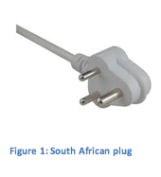

Wi-fi Access

You will have access to free wi-fi at the School of Public Health, once you have set it up. Sunnyside Park Hotel provides wi-fi in rooms and public areas.

Meals

Morning and afternoon coffee/tea breaks are provided on days when there are formal workshop sessions, but not during project work. For those staying at the Sunnyside Park, a breakfast buffet is included in the room price. You are responsible for all other meals (except for lunch on Monday, August 10, and Friday, August 14, and the closing dinner on Thursday, August 13). Olives and Plates at the Faculty of Health Sciences cafeteria (across the street from the School of Public Health) offers vegetarian, kosher and halal options.

HOTEL BOOKING FORM
(WITS UNIVERSITY UNICEF CONFERENCE 2014)

Please complete form and fax directly to Hotel to make your reservation:
Att: Reservations – Mary
Fax: (011) 642-0019 Tel: (011) 640-0400/0431
Email: sunnyside1@legacyhotels.co.za

PERSONAL DETAILS
Name
Postal Address
Tel Number |  |  | Fax Number
Method of Payment |  |  | Credit Card No
(Credit Card guarantees booking) |  |  | Exp. Date

ACCOMMODATION
ARRIVAL DATE | DEPARTURE DATE | NO OF ROOMS | RESERVATION NO  (Completed by Hotel)
Standard check-in time is 14H00 and check-out time is 11H00.

TRANSPORT REQUESTS
Airport Collection | Yes |  | No |  | Flight Number |  | Arrival Time
Airport Return | Yes |  | No |  | Flight Number |  | Departure Time

(Costs from +/- ZAR450—about US $40- person per trip currently for Airport Transfers – Charged onto hotel account – Prices are subject to change without notice)

RATES
- Single Room @ R1024.00 (About 84 US) per night, bed and breakfast

* Rates include VAT at 14%
* Are Inclusive of a Full English Buffet Breakfast
* Rates are valid from 1st January 2015 to 31st December 2015
* Are subject to change without prior notice

