COMMUNICATION FOR DEVELOPMENT (C4D) WORKSHOP
Hosted by the Department of Communication, University of Hyderabad, India
Taj Deccan Hotel, Banjara Hills, Hyderabad
Sunday, July 31 – Friday, August 12, 2016

ADMIN NOTES AND PRE-DEPARTURE AND
ARRIVAL INFORMATION

***Please print a copy to take along while traveling to the workshop***

India Visa

You will need a visa for India even if you are travelling on a UNLP. You will receive a letter of invitation from UNICEF HQ to support your visa application.

If you have any questions on visa application processes, your Operations Office can help you on documentation for the application. In some countries it can take several weeks to obtain a visa, so we urge you to begin the application process as soon as possible.

Travel to Hyderabad and DSA

Travel to Hyderabad should be on economy class. Your country/regional office will provide you with DSA. One dinner (Thursday, August 11) and one lunch (Friday, August 12) will be provided.

We recommend you arrive by Saturday evening, July 30, giving you time to rest before the orientation session at 6:00 p.m. on Sunday July 31.

If your flight is delayed, and you will not arrive in time for the Sunday orientation, please e-mail workshop coordinator Vasuki Belavadi at vb@uohyd.ac.in

From Airport to Hotel

The workshop will be held at the Taj Deccan hotel, https://vivanta.tajhotels.com/en-in/deccan/ in the Banjara Hills area of Hyderabad. We recommend participants stay at this hotel, benefitting from UNICEF’s negotiated conference rate (including breakfast). The airport is about 20 km from Hyderabad’s Rajiv Gandhi International Airport, a 30-45-minute taxi ride (depending on traffic). Two companies operated by the airport authority provide metered taxis:
MERU (040-44224422)
SKY Cabs (040-49494949)

Taxis depart from the plaza one level down from the arrivals hall. The fare is about INR 700 ($10-12) during the day and evening, higher after midnight. The driver can print a receipt.

Health Information

We recommend you consult the Centers for Disease Control for updated information for travelers to India:

http://wwwnc.cdc.gov/travel/destinations/traveler/none/india

The CDC says malaria is a “moderate risk” in all areas of India (except in high-altitude regions) and recommends atovaquone-proguanil, doxycycline, or mefloquine. CDC also recommends vaccinations for Hepatitis A and Typhoid.

There is no risk of yellow fever in India. The government of India requires proof of yellow fever vaccination only if you are arriving from a country with risk of yellow fever. This does not include the US. If you are traveling from a country other than the US, check this list to see if you may be required to get the yellow fever vaccine:

Countries with risk of yellow fever virus (YFV) transmission.

Vaccination should be done at least 10 days before departure for India as the vaccine offers protection 10 days after administration. If the vaccination is administered less than 10 days before departure, you may be refused entry.

Workshop Contacts

Vasuki Belavadi, workshop coordinator, +91 939 300 2297 vb@uohyd.ac.in
Vinod Pavarala, workshop director, + 91 944 072 4914 vpavarala@gmail.com
David Mould, course director, +91 733 749 5643 davidhmould@gmail.com

Orientation Session

The workshop begins with a mandatory orientation session at 6:00 p.m. on Sunday, July 31, with welcomes from the UNICEF India Country Office and the University of Hyderabad. It will be held in the Synergy Room, Executive Level of the Taj Deccan Hotel. During the orientation, you will meet the other members of your NGO project team and team facilitator. This session will be followed by a reception.

Accommodation

Most participants will be staying at the Taj Deccan Hotel:

Address: Road No. 1, Banjara Hills, Hyderabad, Telangana State - 500034
Phone +91 40 66523939
https://vivanta.tajhotels.com/en-in/deccan/
E-mail: tdhresv.hyd@tajhotels.com

We have reserved a block of rooms; the group rate (including buffet breakfast and wi-fi) is INR 5,500 ($81.50) for single occupancy, INR 6,500 ($96) for double. These rates are inclusive of 22% taxes. Please use the attached form to book your room. The hotel will begin accepting bookings on June 12, and close on July 15, after which the conference rate is not guaranteed. If you are not able to use a credit card to hold the room, the hotel is requesting a wire transfer. Please direct all questions regarding accommodation to Ms. Rajshri Thakur, tdhresv.hyd@tajhotels.com.

If you would like to share a room, please contact other participants using the course Facebook page, https://www.facebook.com/groups/unicefc4d2012/ . This is a closed group so you’ll need to click on the “Join Group” button so Belen can accept your request.

Other accommodation options are available in the Banjara Hills area but not at the UNICEF-negotiated conference rate.

If you will arrive a day late due to flight or other delay, please email or call the hotel to avoid being charged for the night.

Meals and Shopping in Banjara Hills

Two shopping malls (GVK One and City Centre) with food courts are within walking distance (7-10 minutes) of the Taj Deccan. A supermarket, Mores, is also within a few minutes’ walk (see map).

Map: GVK One and City Centre Malls

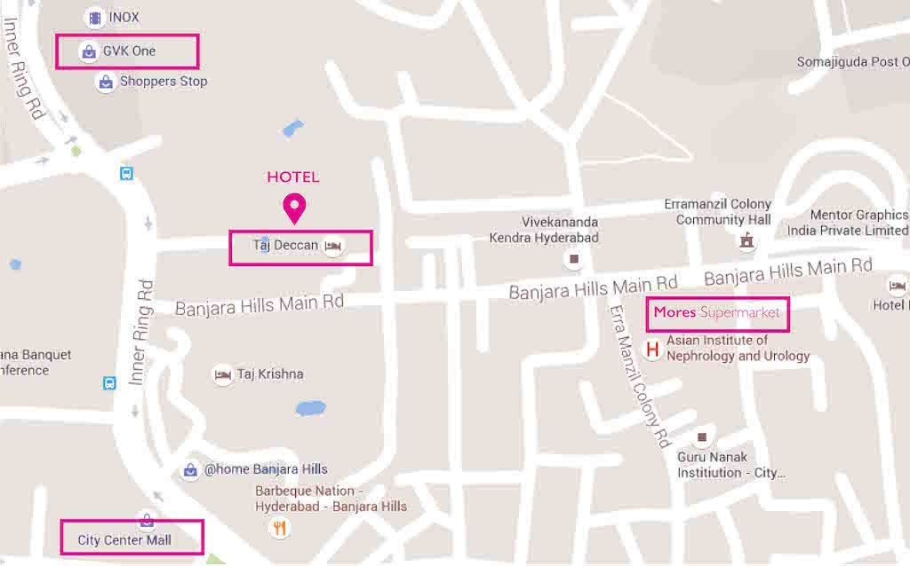

____________________________________________________________________________

C4D Marketplace

We’re planning a C4D MARKETPLACE for the final morning of the workshop, Friday, August 12. The Marketplace is an opportunity to share your experiences in using C4D for UNICEF and discuss what’s worked (maybe also what hasn’t worked) with your colleagues. We’ll set up tables so you can display print materials or pictures, play a DVD, show a website or just tell a story. We hope you’ll start thinking now about what to bring/present at the Marketplace. The Marketplace will be followed by a light lunch.

Safety and security

A few basic precautions are recommended. All hotels have safes (in the room or on the premises). We advise you to lock away all valuables, passports, and cameras (when not in use). When walking in Hyderabad, valuables should be carried discreetly.

Money

Currency is the Indian rupee (INR). U.S. dollars and travellers’ checks are usually not accepted. ATMs are available at banks, shops and malls. We suggest you use an ATM or change money at the airport to pay for the taxi. The Taj Deccan does not have an ATM, but there are ATMs at the two nearby malls and at Mores supermarket.

Note: A good site for calculating currency rates is: http://www.oanda.com/currency/converter/

Phones and SIM cards

Several companies (including Airtel and Vodafone) offer SIM cards. You’ll need to provide the following documentation:
- Copy of passport face page
- Copy of India visa
- One passport photo
- Proof of local address (letter from hotel)
It may take up to 24 hours after purchase for the number to be activated.

What to Pack

Temperatures in August range from 26 to 30 Celsius. It’s the rainy season, so bring an umbrella.
Bring comfortable walking shoes for your trips to your NGO, and a laptop computer for group work. You may want to bring small gifts from our country for the NGO staff.

Please also print a copy of your passport face page, and a copy of your official workshop invitation letter. We advise you to leave your passport in the hotel safe.

Electrical Supply and Power Adaptors

India uses 230 Volts, 50 Hz AC. Plugs and sockets have either ungrounded two pin connections (Type C, common in Europe, Asia and Latin America) or grounded/earthed three-pin connections (Types D and M). Rooms in the Taj Deccan have outlets that accept multiple plugs (without adaptors).

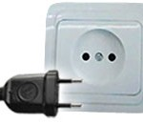
Type C--two pin ungrounded
Type D--three pin grounded
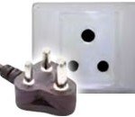
Type M--three pin grounded

Meals

Morning and afternoon coffee/tea breaks are provided on days when there are formal workshop sessions, but not during project work. For those staying at the Taj Deccan, a breakfast buffet is included in the room price. You are responsible for all other meals (except for the closing dinner on Thursday, August 11, and lunch on Friday, August 12). The Taj Deccan has two restaurants; there are food courts at both malls and other restaurants nearby in Banjara Hills.

